Second Part of the Term Project -- due on Dec 6

Make a table of 100x10 random numbers exponentially distributed with mean 4.5 -- use two digits after decimal point (do not use too many digits)

Let X denote the average of 10 numbers in each row.

- Calculate sample mean and variance of 1000 numbers
- Calculate sample mean and variance of X for 100 rows
- Compare your results with the theoretical values

Calculate P(X<2) using normal approximation and compare this with your observation in the table.

Here is the formula to obtain each number: -ln(rand())*mean

Your report is limited by two sides of an A4 sheet

Include all the formulas used in your calculation

Do not attempt to show all of the table, it won't fit

Partial solution of the first part: note that V(X) = V(U)/10

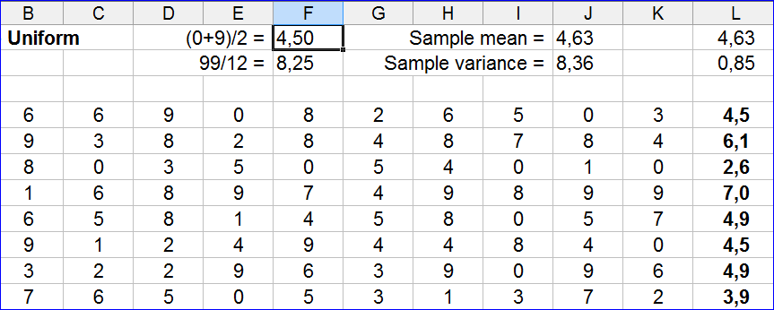
First Part of the Term Project -- due on Nov 3

Make a table of 100x10 random digits using Java, R, Excel, Matlab or similar
software. Let X denote the average of 10 digits in each row.

- Calculate sample mean and variance of 1000 digits

- Calculate sample mean and variance of X for 100 rows

- Compare your results with the theoretical values

The project will be divided to 3 or 4 parts -- this is the first part

Your report is limited by two sides of an A4 sheet

Include all the formulas used in your calculation

Do not attempt to show all of the table, it won't fit
About the Project
1. Projects can be done alone or by two students. If you submit teamwork (of two students) submit only one copy and clearly indicate both names

Ödevi iki kişi yaptıysa, tek kopya verip her iki ismi de belirtin.

2. Do not make a cover page, do not use plastic covers, use as few pages as possible, be environment-friendly.
Kapak sayfası yapmayın, plastik dosya kullanmayın. Az kağıt kullanıp çevreye az zarar verelim.

3. Plagiarism (for the assignments and in the exams) is a very serious offense that can result in a failing grade for the course
Ödevlerde/sınavlarda kopya çekmek, dersten F alma sonucunu getirebilen çok ciddi bir suçtur

